ASSIGNMENT 2

Q1. Printing your machine’s name and IPv4 address?

import socket

import fcntl

import struct

def get_ip_address(ifname):

s = socket.socket(socket.AF_INET, socket.SOCK_DGRAM)

return socket.inet_ntoa(fcntl.ioctl(

s.fileno(),

0x8915, # SIOCGIFADDR

struct.pack('256s', ifname[:15])

)[20:24])

hostname = socket.gethostname()

print("Mahcine Name is: " + hostname)

print("Machine IPv4 Address is: " + get_ip_address('eth0'))

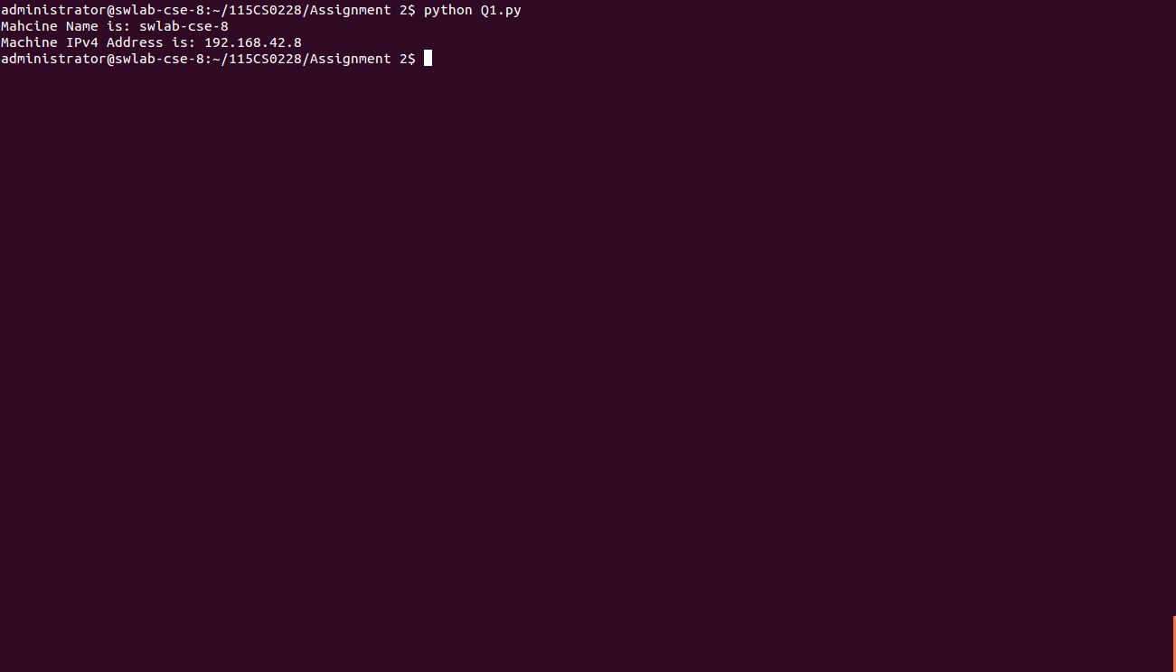

Q2. Retrieve a remote machine’s IP address and convert the IP address to

different format?

import socket

from binascii import hexlify

def get_remote_machine_details():

remote_host = "www.nitrkl.ac.in"

ip_addr = socket.gethostbyname(remote_host)

try:

print "IP address of "+remote_host+" : "+ip_addr

return ip_addr

except socket.error, err_msg:

print "%s: %s" %(remote_host, err_msg)

def convert_ip_addr(ip_addr):

packed_ip_addr = socket.inet_aton(ip_addr)

unpacked_ip_addr = socket.inet_ntoa(packed_ip_addr)

print "IP Address: %s => Packed: %s, Unpacked: %s"\

%(ip_addr, hexlify(packed_ip_addr), unpacked_ip_addr)

ip_addr = get_remote_machine_details()

convert_ip_addr(ip_addr)

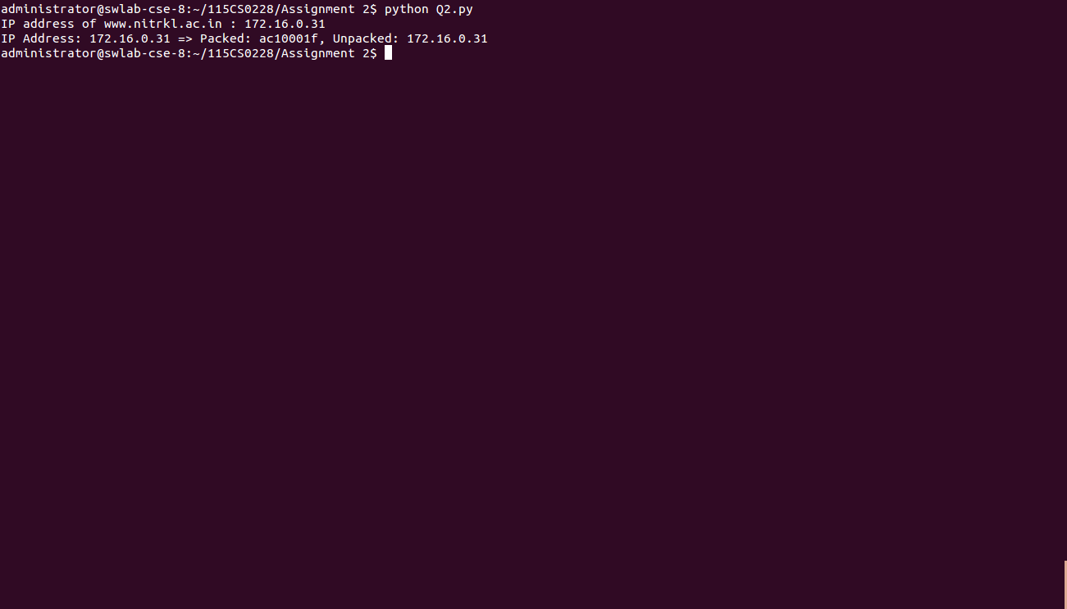

Q3. Setting and getting the default socket timeout, the program should

include how to handle the socket error gracefully?

import sys

import socket

import argparse

def socket_timeout():

s = socket.socket(socket.AF_INET, socket.SOCK_STREAM)

print "Default socket timeout: %s" %s.gettimeout()

s.settimeout(20)

print "Current socket timeout: %s" %s.gettimeout()

def socket_error():

# setup argument parsing

parser = argparse.ArgumentParser(description='Socket Error Examples')

parser.add_argument('--host', action="store", dest="host",required=False)

parser.add_argument('--port', action="store", dest="port",type=int, required=False)

parser.add_argument('--file', action="store", dest="file",required=False)

given_args = parser.parse_args()

host = given_args.host

port = given_args.port

filename = given_args.file

# First try-except block -- create socket

try:

s = socket.socket(socket.AF_INET, socket.SOCK_STREAM)

except socket.error, e:

print "Error creating socket: %s" % e

sys.exit(1)

# Second try-except block -- connect to given host/port

try:

s.connect((host, port))

except socket.gaierror, e:

print "Address-related error connecting to server: %s" % e

sys.exit(1)

except socket.error, e:

print "Connection error: %s" % e

sys.exit(1)

# Third try-except block -- sending data

try:

s.sendall("GET %s HTTP/1.0\r\n\r\n" % filename)

except socket.error, e:

print "Error sending data: %s" % e

sys.exit(1)

while 1:

# Fourth try-except block -- waiting to receive data from remote host

try:

buf = s.recv(2048)

except socket.error, e:

print "Error receiving data: %s" % e

sys.exit(1)

if not len(buf):

break

# write the received data

sys.stdout.write(buf)

socket_timeout()

socket_error()

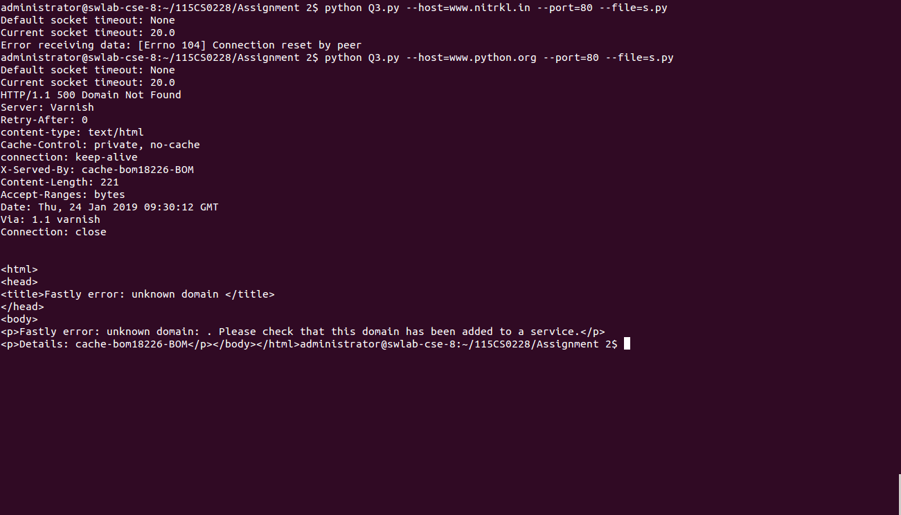

Q4. Finding the service name, given the port and protocol of the remote host

(server)?

import socket

def get_service_name():

protocolname = 'tcp'

for port in [80, 25]:

print "Port: %s => service name: %s" %(port, socket.getservbyport(port, protocolname))

print "Port: %s => service name: %s" %(53, socket.getservbyport(53, 'udp'))

get_service_name()

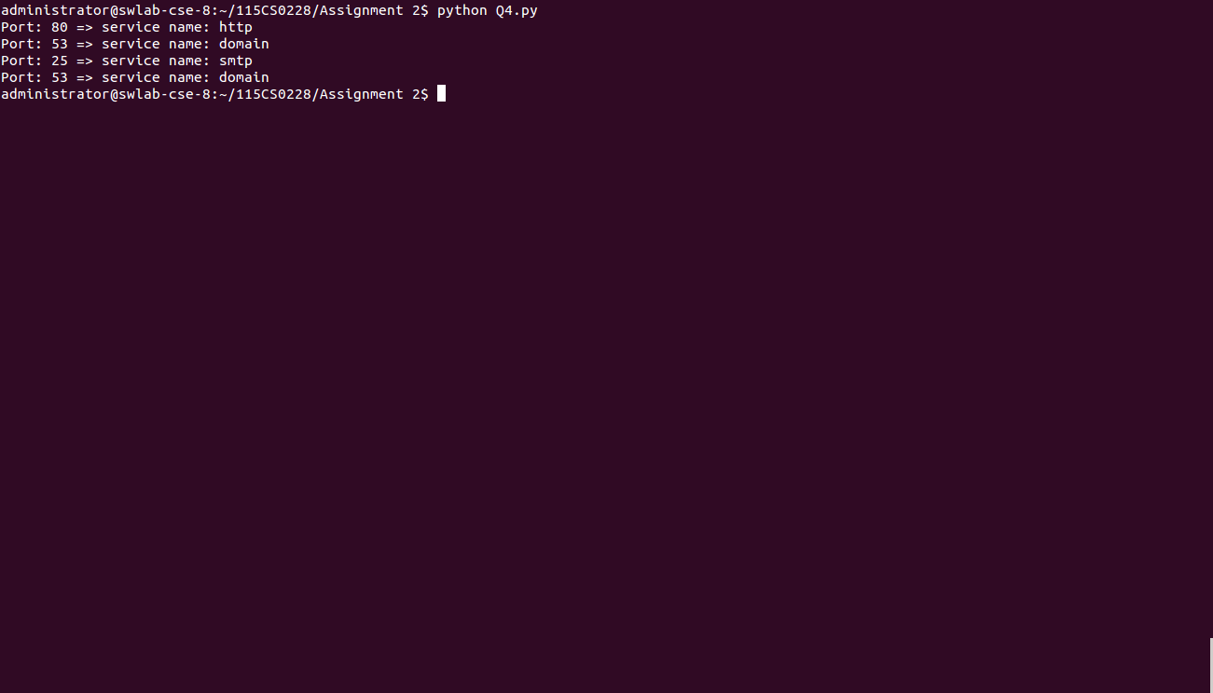

Q5. Printing the current time from the internet time server with the help of NTP? Also write an SNTP client that prints the current time from the internet time server received with the SNTP protocol?

import socket

import struct

import sys

import time

import ntplib

from time import ctime

def get_time():

c = ntplib.NTPClient()

response = c.request('pool.ntp.org')

print(ctime(response.tx_time))

def sntp_client():

NTP_SERVER = "0.uk.pool.ntp.org"

TIME1970 = 2208988800L

client = socket.socket(socket.AF_INET, socket.SOCK_DGRAM)

data = '\x1b' + 47 * '\0'

client.sendto(data, (NTP_SERVER, 123))

data, address = client.recvfrom( 1024 )

if data:

print 'Response received from:', address

t = struct.unpack( '!12I', data )[10]

t -= TIME1970

print '\tTime=%s' % time.ctime(t)

sntp_client()

get_time()

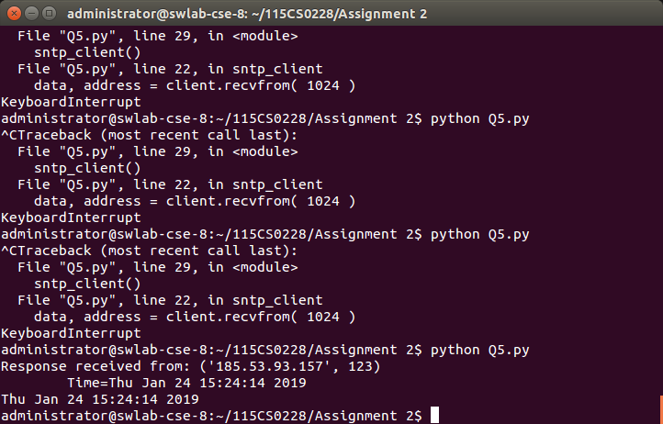

Q6. Modifying sockets send/receive buffer size and changing the socket to

blocking/non‐blocking mode?

import socket

SEND_BUF_SIZE = 4096

RECV_BUF_SIZE = 4096

def update_buffer():

sck = socket.socket(socket.AF_INET, socket.SOCK_STREAM )

# Get the size of the socket's send buffer

bufsize = sck.getsockopt(socket.SOL_SOCKET, socket.SO_SNDBUF)

print "Intial Buffer size :%d" %bufsize

sck.setsockopt(socket.SOL_TCP, socket.TCP_NODELAY, 1)

sck.setsockopt(socket.SOL_SOCKET,socket.SO_SNDBUF,SEND_BUF_SIZE)

sck.setsockopt(socket.SOL_SOCKET,socket.SO_RCVBUF,RECV_BUF_SIZE)

bufsize = sck.getsockopt(socket.SOL_SOCKET, socket.SO_SNDBUF)

print "Updated Buffer size :%d" %bufsize

def block_modes():

s = socket.socket(socket.AF_INET, socket.SOCK_STREAM)

s.setblocking(1)

s.settimeout(0.5)

s.bind(("127.0.0.1", 0))

socket_address = s.getsockname()

print "Trivial Server launched on socket: %s" %str(socket_address)

#while(1):

#s.listen(1)

update_buffer()

block_modes()

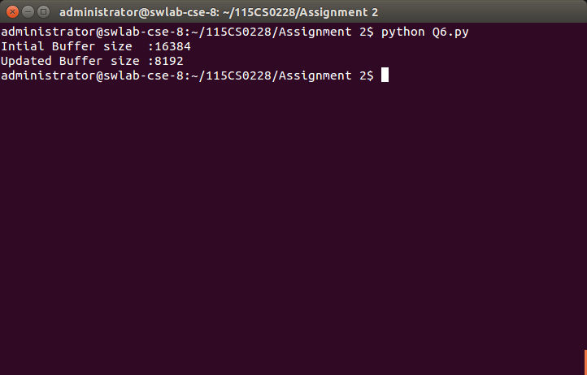

Q7. Write a program that demonstrates the reuse socket addresses?

import socket

import sys

def socket_reuse():

sock = socket.socket( socket.AF_INET, socket.SOCK_STREAM )

# Get the old state of the SO_REUSEADDR option

old_state = sock.getsockopt(socket.SOL_SOCKET, socket.SO_REUSEADDR)

print "Old sock state: %s" %old_state

# Enable the SO_REUSEADDR option

sock.setsockopt( socket.SOL_SOCKET, socket.SO_REUSEADDR, 1 )

new_state = sock.getsockopt( socket.SOL_SOCKET, socket.SO_REUSEADDR )

print "New sock state: %s" %new_state

local_port = 8282

srv = socket.socket(socket.AF_INET, socket.SOCK_STREAM)

srv.setsockopt(socket.SOL_SOCKET, socket.SO_REUSEADDR, 1)

srv.bind( ('', local_port) )

srv.listen(1)

print ("Listening on port: %s " %local_port)

while True:

try:

connection, addr = srv.accept()

print 'Connected by %s:%s' % (addr[0], addr[1])

except KeyboardInterrupt:

break

except socket.error, msg:

print '%s' % (msg,)

socket_reuse()

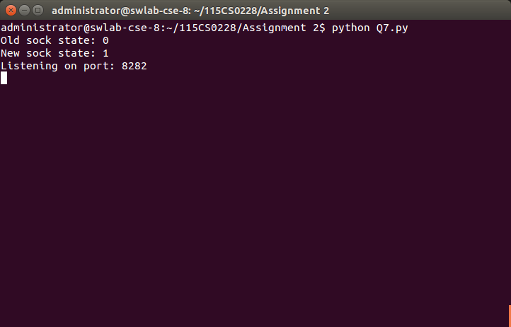

Q8. Write a simple TCP echo client/server application with the help of TCP socket object. The server wait for the client to be connected and send some data to the server. When the data is received, the server echoes the data to the client.

SERVER.PY

import socket

import sys

import argparse

host = 'localhost'

data_payload = 2048

backlog = 5

def echo_server(port):

""" A simple echo server """

# Create a TCP socket

sock = socket.socket(socket.AF_INET, socket.SOCK_STREAM)

# Enable reuse address/port

sock.setsockopt(socket.SOL_SOCKET, socket.SO_REUSEADDR, 1)

# Bind the socket to the port

server_address = (host, port)

print "Starting up echo server on %s port %s" % server_address

sock.bind(server_address)

# Listen to clients, backlog argument specifies the max no. of

queued connections

sock.listen(backlog)

while True:

print "Waiting to receive message from client"

client, address = sock.accept()

data = client.recv(data_payload)

if data:

print "Data: %s" %data

client.send(data)

print "sent %s bytes back to %s" % (data, address)

# end connection

client.close()

if __name__ == '__main__':

parser = argparse.ArgumentParser(description='Socket Server

Example')

parser.add_argument('--port', action="store", dest="port",

type=int, required=True)

given_args = parser.parse_args()

port = given_args.port

echo_server(port)

CLIENT.PY